Deployment.yaml

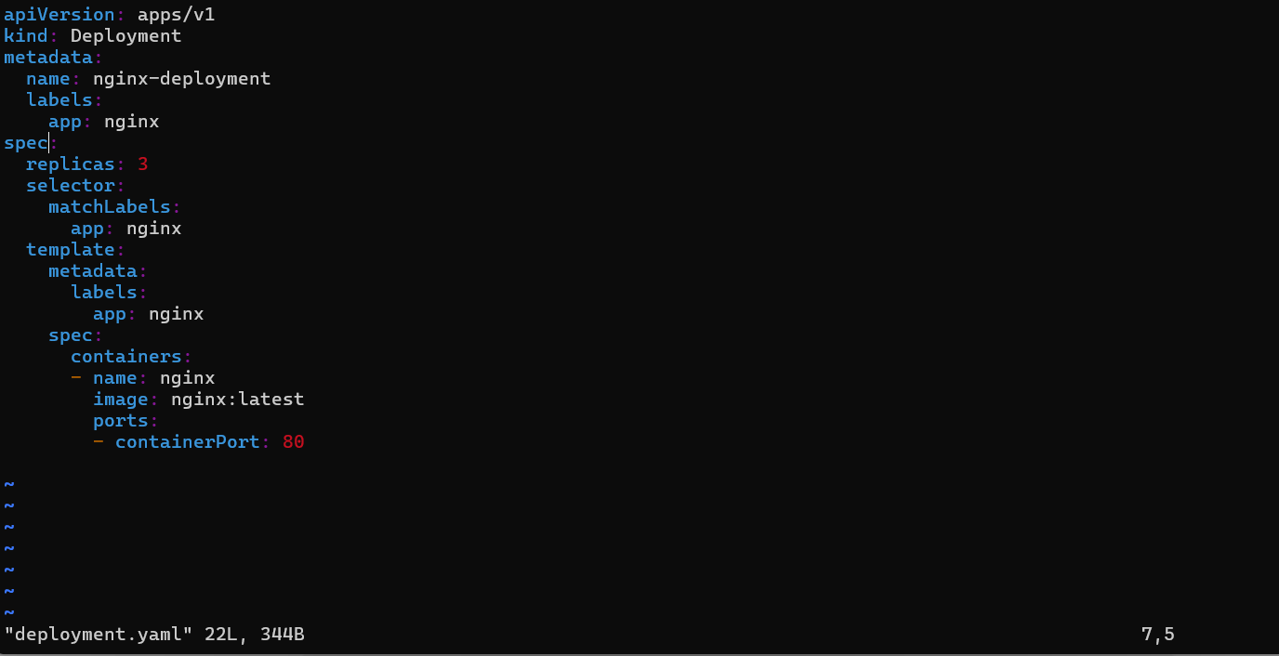

Output

Services.yaml

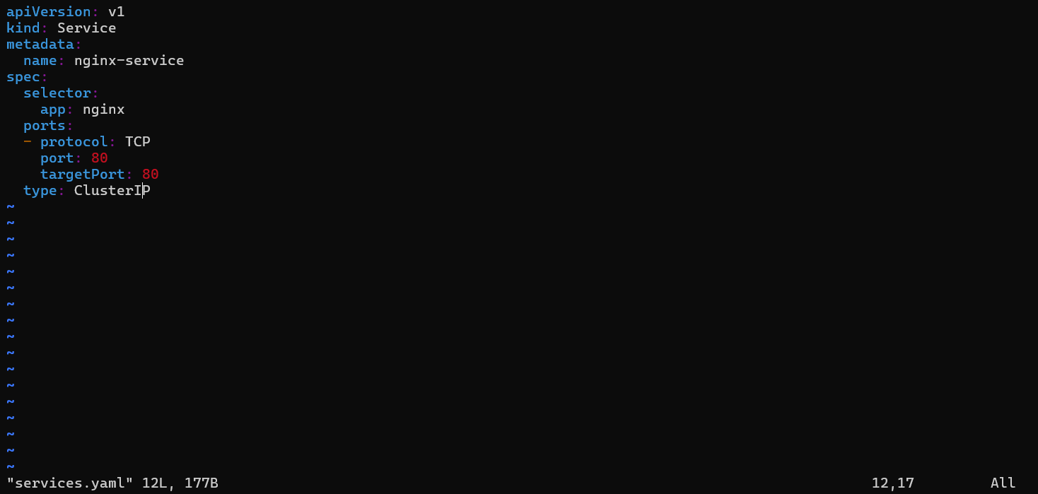

Output:

